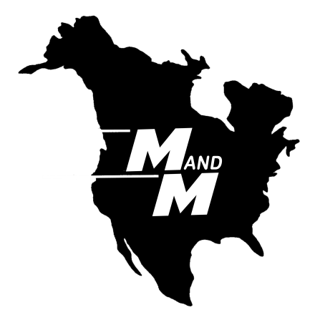

M and M Forwarding of Buffalo
600 Main Street, PO Box 888
Tonawanda, 14151-0888

Phone: 716-692-1825
Toll Free: 800-874-1825
Fax: 716-692-0056

Position Title: International Dispatch Clerk
Position ID: MMFB 2013-15
Date Posted: November 27, 2013

Position Overview
M and M Forwarding has an opening for an International Dispatch Clerk. This individual would be responsible for the coordination of the paperwork, loads and routes for all M and M cross border deliveries and pickups. The primary objective of the individual in this role will be to expedite freight to meet the deadlines and demands of the M and M clients through proper utilization of M and M resources. The incumbent will interact with a wide variety of people to accomplish their objectives including internal warehouse, operations and sales staff, drivers, clients, customs brokers, partner carriers and equipment suppliers This hourly position will train under and report to the Director of Dock, Warehouse and Freight Operations and will be located at the dispatch desk in the dock office.

Experience and Skills Required
We are willing to train the right person for this position but a background as a Clerk in a Customs Broker’s office having a working knowledge of the filings and clearance process is highly preferred. The person best suited to this role is one who has a track record of solving problems, keep deadlines and managing resources in a fast paced environment where daily closure is mandatory.

Candidates will need to demonstrate a comfort with computers and fluency in Microsoft Office as well as the ability to quickly adapt to and use other internal and web based systems.

To Learn More
If you are looking for a position that provides a “daily scoreboard” of how well you have done (on-time deliveries and pickups) combined with unique daily challenges that keep it interesting, then send your resume and a cover letter that must include the following:
- The specific job or specific experience you have had that is closest to the daily requirements for this job.
- Your salary and compensation requirements. Resumes that are received without this information will not be considered.
Send this information to Hiring@MMForward.com. Please, no phone calls or walk-ins.

